Snackable Pocket Demo Set Up Instruction:

Azure SQL geospatial Services for FSI Scenario

Part of the **Financial Services Industry Scenario DREAM Demo**

For demo feedback and other questions please email daidemos@microsoft.com.

For demo environment issues, please email cloudlabs-support@spektrasystems.com.

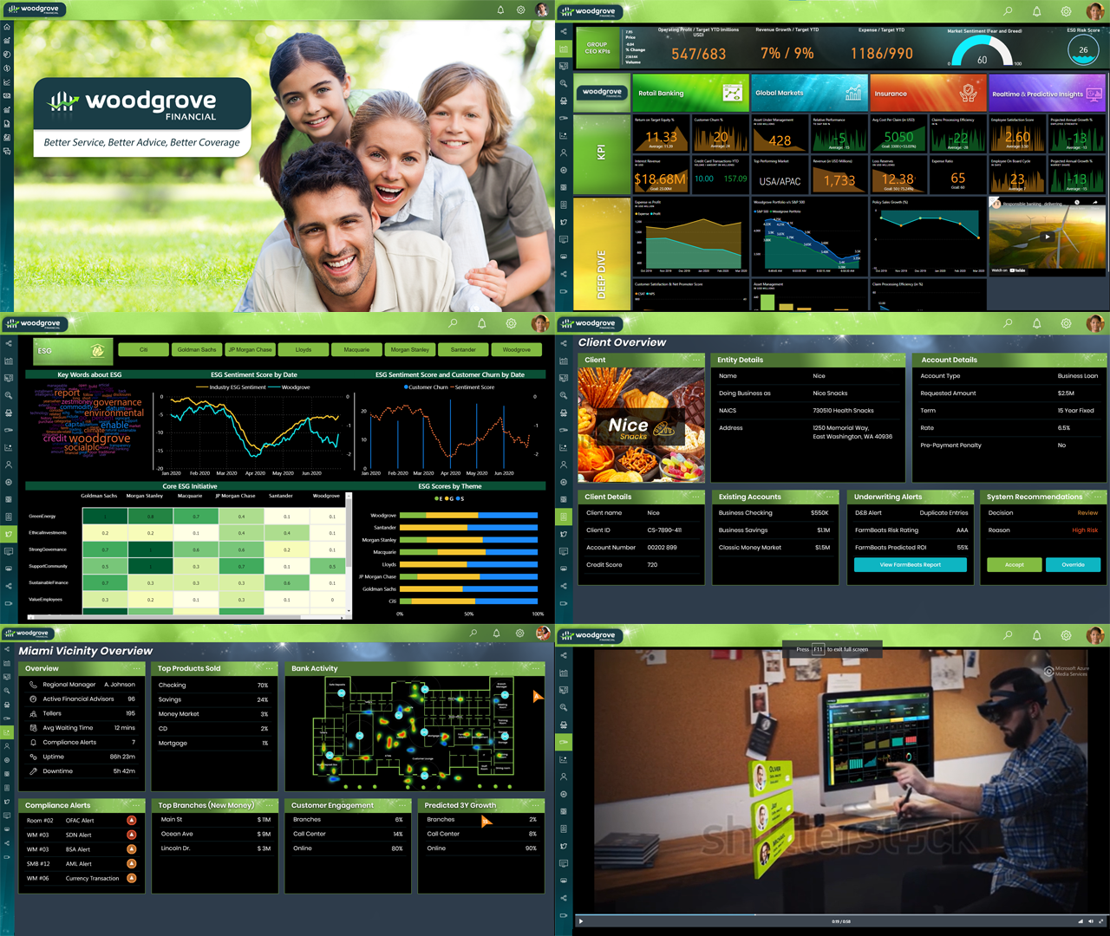

| **IMPORTANT NOTE: Set up your demo environment one hour before your scheduled demo to make sure everything is working. For access problems, please email**[**cloudlabs-support@spektrasystems.com**](mailto:cloudlabs-support@spektrasystems.com)**.  For demo feedback and other questions please email**[**daidemos@microsoft.com**](mailto:daidemos@microsoft.com) | |
| --- | --- |
| **Steps** | **Screenshot** |
| **PLEASE USE Microsoft EDGE based on CHROMIUM**for the below stepsto enablecopying and pasting credentials directly from the browser. There is a known issue with Edge browser where the copy / paste for credentials doesn’t work. To download Microsoft Edge based on Chromium, please go [here](https://support.microsoft.com/en-us/help/4501095/download-microsoft-edge-based-on-chromium).     1. **Click** on the link below to get to the login page:   <https://admin.cloudlabs.ai>   1. **Click** on the **LOG IN** button on the top right-hand corner. |  |
| 1. Click on **Work or School Account** |  |
| 1. Login using your **Microsoft Account** to log into the Cloudlabs portal. |  |
| 1. After Logging in, **click** on the drop down on the top right-hand corner to change the tenant to **Microsoft Demo.** |  |
| 1. Click on **Test Drives** and then click on the **NEW LAB** button. 2. After clicking on New Lab button, you will be able to see all the labs/demos enabled as Test Drive. |  |
| 1. On the search bar, type **Financial Services Industry Scenario DREAM Demo** Click on the **Test Drive** button when the demo shows up. |  |
| 1. You will be redirected to a page to launch the lab. **Click** on the **LAUNCH LAB** button to create the demo environment. |  |
| 1. Upon clicking the Launch Lab button, you will be redirected to a browser page with lab details. 2. **Click** on ‘Environment Details’. 3. **Click** on ‘Azure Credentials’. |  |
| 1. **Click** on ‘Resource URLs and Credentials’. |  |
| 1. **Copy** the URL (https://storagep7cjlb2iaspd2...) from the lab details page and paste it into an InPrivate window in Edge Chromium. |  |
| 1. **Click** on “Financial Services Industry Scenario DREAM Demo –Pocket ‘Snackable’ demos”. |  |
| 1. **View** the list of all the snackable demos. |  |
| 1. **Expand “**20. Azure SQL geospatial Services for FSI” and **click “**Woodgrove Financial Application” & “Azure Download SQL Server Management Studio”. |  |
| 1. **Sign in** with the **Azure Credentials** from the lab details page that is now open back in your own browser - see screenshot on right. Cut and paste these credentials in your own browser. |  |
| 1. **Choose YES** when prompted to “Stay Signed In”. 2. For this Snackable, you only need to Sign into “**Azure Synapse Analytics**” Tab. |  |
| **IMPORTANT NOTE: Set up your demo environment one hour before your scheduled demo to make sure everything is working. For access problems, please email** [**cloudlabs-support@spektrasystems.com**](mailto:cloudlabs-support@spektrasystems.com)**. For demo feedback and other questions please email** [**daidemos@microsoft.com**](mailto:daidemos@microsoft.com) | |

Microsoft Corporation. All rights reserved.

By using this demo/lab, you agree to the following terms:

The technology/functionality described in this demo/lab is provided by Microsoft Corporation for purposes of obtaining your feedback and to provide you with a learning experience. You may only use the demo/lab to evaluate such technology features and functionality and provide feedback to Microsoft. You may not use it for any other purpose. You may not modify, copy, distribute, transmit, display, perform, reproduce, publish, license, create derivative works from, transfer, or sell this demo/lab or any portion thereof.

COPYING OR REPRODUCTION OF THE DEMO/LAB (OR ANY PORTION OF IT) TO ANY OTHER SERVER OR LOCATION FOR FURTHER REPRODUCTION OR REDISTRIBUTION IS EXPRESSLY PROHIBITED.

THIS DEMO/LAB PROVIDES CERTAIN SOFTWARE TECHNOLOGY/PRODUCT FEATURES AND FUNCTIONALITY, INCLUDING POTENTIAL NEW FEATURES AND CONCEPTS, IN A SIMULATED ENVIRONMENT WITHOUT COMPLEX SET-UP OR INSTALLATION FOR THE PURPOSE DESCRIBED ABOVE. THE TECHNOLOGY/CONCEPTS REPRESENTED IN THIS DEMO/LAB MAY NOT REPRESENT FULL FEATURE FUNCTIONALITY AND MAY NOT WORK THE WAY A FINAL VERSION MAY WORK. WE ALSO MAY NOT RELEASE A FINAL VERSION OF SUCH FEATURES OR CONCEPTS. YOUR EXPERIENCE WITH USING SUCH FEATURES AND FUNCITONALITY IN A PHYSICAL ENVIRONMENT MAY ALSO BE DIFFERENT.

**FEEDBACK**. If you give feedback about the technology features, functionality and/or concepts described in this demo/lab to Microsoft, you give to Microsoft, without charge, the right to use, share and commercialize your feedback in any way and for any purpose. You also give to third parties, without charge, any patent rights needed for their products, technologies, and services to use or interface with any specific parts of a Microsoft software or service that includes the feedback. You may not give feedback that is subject to a license that requires Microsoft to license its software or documentation to third parties because we include your feedback in them. These rights survive this agreement.

MICROSOFT CORPORATION HEREBY DISCLAIMS ALL WARRANTIES AND CONDITIONS WITH REGARD TO THE DEMO/LAB, INCLUDING ALL WARRANTIES AND CONDITIONS OF MERCHANTABILITY, WHETHER EXPRESS, IMPLIED OR STATUTORY, FITNESS FOR A PARTICULAR PURPOSE, TITLE AND NON-INFRINGEMENT. MICROSOFT DOES NOT MAKE ANY ASSURANCES OR REPRESENTATIONS WITH REGARD TO THE ACCURACY OF THE RESULTS, OUTPUT THAT DERIVES FROM USE OF DEMO/ LAB, OR SUITABILITY OF THE INFORMATION CONTAINED IN THE DEMO/LAB FOR ANY PURPOSE.

**DISCLAIMER**

This demo/lab contains only a portion of new features and enhancements in Microsoft products. Some of the features might change in future releases of the product. In this demo/lab, you will learn about some, but not all, new features.